Laboratory 9 Enumeration

Introduction

One of the central questions a researcher asks when studying any bacterial system is “how many bacteria are present in this sample?” This applies to environmental samples where we want to learn about a native population as well as to lab cultures where we are measuring physiological functions. There are many ways to count bacteria and each of them has advantages and disadvantages.
Measuring the optical density (O.D.) of a sample is an indirect method of determining the number of cells present. The amount of light of a specific wavelength that is absorbed by a culture is related to the number of cells. This is a very fast and easy way to count cells when possible. Unfortunately, in order to use this method, you first need to calculate a response factor (the ratio of the number of cells to the change in absorbance) for the specific cells and media that you are using. This requires use of an independent method for counting the cells.
Another common method for counting cells is to serially dilute the original sample and spread-plate the resulting dilutions. This is known as the plate-count method. The colonies that arise after incubation are counted to determine the original cell density. This method requires more time and supplies than measuring the optical density but it does result in an absolute number of cells rather than a relative value. The one important thing to remember when doing plate-counts is that it only counts the viable cells (those cells that are able to grow under the specific incubation conditions used).
If you want to count all of the cells present in a sample then a direct-counting method should be chosen. This generally involves using a microscope to visualize the cells. Special microscope slides that have surfaces calibrated into precise volumes can be used to determine exactly how many cells there are in a milliliter of sample. Sometimes stains are used to make the cells more visible. This method counts all cells whether they are alive or not. The decision as to whether viable or total cell counts are more relevant will depend on the experimental question being asked.
In this lab you will be counting the number of bacteria in an overnight culture of E. coli using three different methods: optical density, direct counts and plate counts. You will then be able to calculate a response factor for optical density and compare the direct count and viable count methods.

Materials

Equipment
- spectrophotometer
- microscopes
- Petroff-Hauser chamber
- bunsen burners
- spreaders

Cultures
- Escherichia coli (broth)

Supplies
- Nutrient Agar (NA) plates
- Liquid NB media
- Pasteur pipettes and bulbs
- Methylene Blue stain
- 95% ethanol

Procedures

Plate-Counts (Counting by Dilution Series)

Period 1
- Make a dilution series of the E. coli culture in liquid NB media.
- Aseptically transfer 1 ml of the culture into a tube containing 9 ml of NB medium.
- Transfer 1 ml of the resulting tube into another tube with 9 ml of medium.
- Repeat this process until you have produced 8 tubes. (10⁻¹ – 10⁻⁸).
- Spread 0.1 ml of each dilution tube from 10⁻² – 10⁻⁸ onto a NA plate.
- Incubate at 35°C for one day.

Period 2
- Count the number of colonies on plates that contain between 20 and 200 well-separated colonies.
- Calculate the number of cells in the starting culture by multiplying the number of colonies times the inverse of the dilution.

Optical Density (Counting by Spectrophotometer)

- Turn on the spectrophotometer and set it to 525 nm.
- Make a dilution series of the original E. coli culture in liquid NB media.
- Transfer 5 ml of the culture into a tube containing 5 ml of NB medium.
- Transfer 5 ml of the resulting tube into another tube with 5 ml of medium.
- Repeat this process until you have produced 4 new tubes. (1:2 – 1:16).
- Set the transmittance to 0 with no sample in the chamber.
- Set the absorbance to 0 using un-inoculated NB medium as a blank.
- Measure the absorbance of each of the dilution tubes used in the dilution series.
- Plot the absorbance against the dilution factor.

Direct Counting (Petroff-Hauser Chamber)

- Use a pipette to transfer 0.9 ml of the starting culture to a clean test-tube.
- Add 0.1 ml of methylene blue stain to the culture.
- Use a Pasteur pipette to transfer a drop of the stained culture into the Petroff-Hauser slide.
- Carefully place the cover slip onto the calibrated surface of the counting chamber.
- Place the chamber on the microscope stage and focus under the 20X objective to locate the large counting grids.
- Switch to high power and count the number of bacteria in at least 20 of the small squares.
(If there are too many bacteria to count, make a 1:10 dilution of the culture and start over)
- Average the number of cells and calculate the number per ml. (cubic centimeter).

Dilution Series

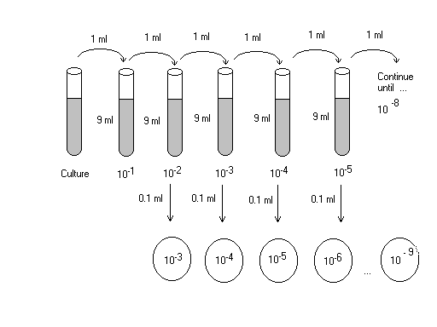

Lab #9 20 points

Name: Date:

Plate counts

Count the number of colonies on plates that contain between 20 and 200 well-separated colonies.
colonies dilution

Calculate the number of cells in the starting culture by multiplying the number of colonies times the inverse of the dilution.

Concentration of cells in starting culture = cells/ml

Optical density

dilution tube absorbance

culture

1:2

1:4

1:8

1:16

Plot the absorbance against the dilution factor. (Attach graph)

Direct counts

Average the number of cells/square and calculate the number per ml. (cubic centimeter). Each small square is 1/20th X 1/20th of one millimeter square and 1/50th of one millimeter deep.

Average number of cells per square -

Cells per milliliter -

Cells per milliliter - (corrected for dilution by dye)

Response factor

Use the absorbance graph, the plate-count data and the direct-count data to calculate two separate response factors (# of cells / absorbance unit) for absorbance at 620nm for E. coli.

Plate count response factor cells/absorbance unit

Direct count response factor cells/absorbance unit

Question:

1). Which response factor is more accurate for correlating absorbance to cell numbers? Why?

2). Give an example of an experiment in which you would want to use a direct count and an example of an experiment in which you would want to use a live count for quantifying bacteria.

